Name | Responsibilities | First Appointed | Term Start | Term End | Governor Type | Declaration of Interest
Katherine Muncaster | Headteacher |  |  |  |  | Educational Author and Trainer
Trudy McLindon | Chair of Governors  Pay Committee  H&S Governor  English, | 01 Jan 2014 | 08 Mar 2022 | 07 Mar 2026 | Co Opted | None
Steve Inch | Vice Chair of Governors  SEND Governor  Languages | 01 Oct 2015 | 15 Oct 2023 | 14 Oct 2023 | Co Opted | None
Nicola Townson | Learning Committee Chair  Art/DT | 02/12/2022 | 02/12/2022 | 01/12/2026 | Co Opted Governor | None
Tropez Martin | Learning Committee  EYFS  PHSE & Re | 01/09/2023 | 01/09/2023 | 31/08/2027 | Co Opted | Governor at St Pauls Church of England School
Karen Bexley | Pay Committee  Music | 16 Jul 2019 | 16 Jul 2023 | 15 Jul 2027 | Co Opted | None
Neil Duffit | Finance Governor  Appeals Panel  History & Geography | 15 May 2018 | 15 May 2018 | 14 May 2022 | Parent Governor | None
Frank Young | Resources  PE | 01/04/2022 | 01/04/2022 | 31/03/2026 | Parent Governor | None
Dr Lucy Dunn | Appeals Panel  Science | 18 Dec 2020 | 18 Dec 2020  18 Dec 2024 | 17 Dec 2024  17 Dec 2028 | Co Opted | None
Kevin Shaw | Learning Committee  Maths | 15 Dec 2023 | 15 Dec 2023 | 14 Dec 2027 | Parent Governor | Chair of Governors Freshfield Nursey  Business interests x 6 Cleaning Companies ***
Faye Bridgehouse | Learning Committee | 31 Jan 2019 | 31 Jan 2019  31/01/2023 | 30 Jan 2023  30/01/2027 | Staff Governor | None
Ceri Barratt | School Business Manager |  |  |  | Associate Governor * | None
- No Voting Rights
*** Kevin Shaw: Business Interests detailed below

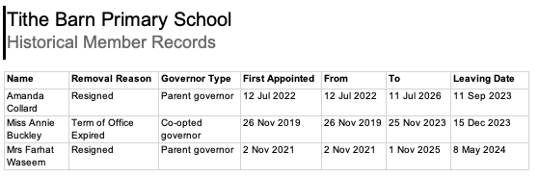

*** Kevin Shaw: Business Interests detailed below

