Curriculum Overview for Year 5/6 –Summer TERM
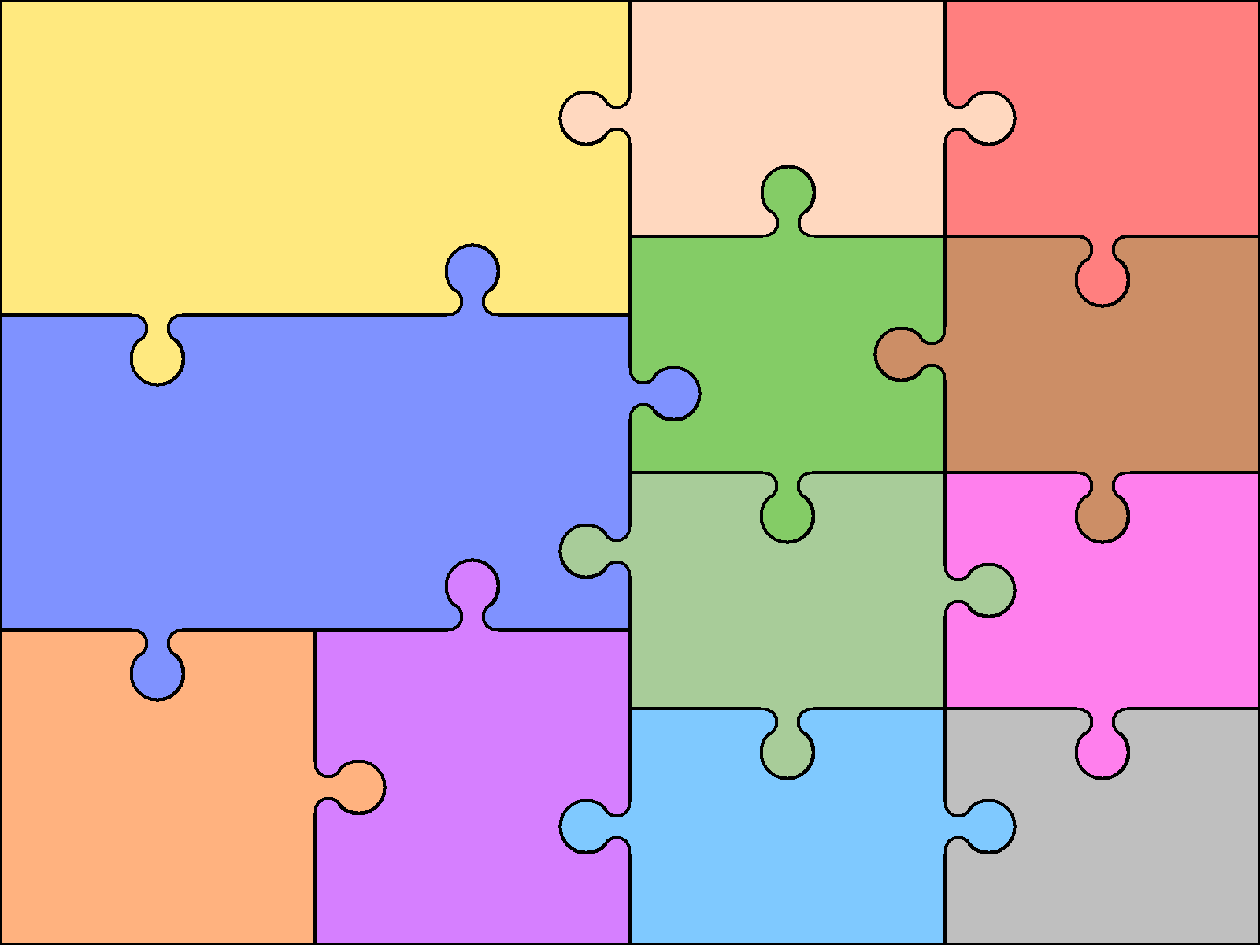 | English |  |  | Art & Design | Computing  - E- safety  - Plan film and edit an advert.  - Design build and collate pages for a year book.  - Applying digital literacy skills (cross-curricular)
 |  |  |  | Design & Technology | Geography  - To understand features and location of countries involved in the conflict (WW2)  - Use maps, grid references  - To understand key aspects of human geography.  - Investigate the Welsh speaking community of Argentina.
GEGEOMETRY & MEASURES: Identify 3-D shapes including cubes and other cuboids from 2-D representations. Find the area and perimeter of various shapes. Translate, reflect and rotate shapes on 4 quadrants. Convert units of measure. Calculate the volume of cubes and cuboids.  STATISTICS: Interpret and draw pie charts (Y6)  NUMBER: Understand place value to 3 decimal places. Add and subtract decimal numbers. Multiply and divide decimal numbers by 10,100 and 1000. Make links between fractions, decimals and percentages. Compare and order decimal numbers. | Mathematics
 |  |  |  | Modern Languages  - Listen & engage in conversations, expressing opinions  - Speak in simple language & be understood  - Develop appropriate pronunciation  - Present ideas & information orally  - Show understanding in simple reading  - Adapt known language to create new ideas  - Describe people, places & things  - Understand basic grammar, e.g. gender | Music  - Perform with control & expression solo & in ensembles  - Improvise & compose using dimensions of music using technology  - Listen to detail and recall aurally  - Use & understand basics of staff notation  - Learn a brass instrument 4 times a week with specialist teacher.
Science  Electricity – voltage, components, symbols.  Living things/Habitats –  Classification incl micro-organisms plants and animals.  NB Year 6 to follow old curriculum for Academic year 2014/15 |  | History
 |  |  |  | Physical Education  - Use running, jumping, catching and throwing in isolation and in combination  - Play competitive games, applying basic principles and tactics.  - Develop coordination and creativity by producing your own dance moves.  - Explore he history of dance.  - Compare performances to achieve personal bests | Religious Education  - Humanism study

