Curriculum Overview for Year 1 Summer Term – The Seaside
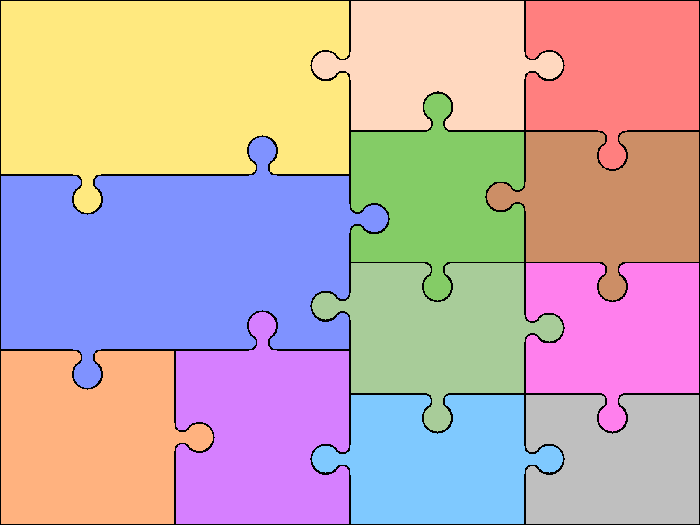  Phonics( spelling)  • Phase 5 of Letters and Sounds. Focus—split digraphs and segmenting and blending alien/real words.  Punctuation and Grammar  • Alphabet order and dictionary work.  • Sentence—joining words and joining clauses using and and using other connectives such as because and so.  • Punctuation - names and the personal pronoun I are capital letters. Use question marks and exclamation marks.  Maths  - Number: Multiplication  and Division  (Reinforce multiples of 2,  5 and 10 to be included)  Making arrays and doubling numbers. | English  • Word—spelling un prefix and ed ending.  • Text—sequencing sentences to form meaning.  Key texts  • Non-fiction texts about Seaside, history of holidays, parts of the body and senses.  • Rhymes and songs about the seaside and parts of the body.  • Key author— Mairi Hedderwick.  - Measurement – Money. Recognising coins and making values.  - Time – dates, language of time, o’clock and half past. |  | Writing Opportunities  • Simple factual writing about the seaside/senses.  • Lists and captions linked to topic work.  • Simple poetry about the seaside.  • Postcards.  - Creating posters/brochures to persuade  people to visit a resort.  . | Art & Design  Drawing  • Lines and marks. Look carefully at shells and complete line drawings.  • Texture—try and represent the texture of shells by rubbing, using pencils in different ways.  3D.  • Create a clay tile decorated with shells/pebbles  Painting  - Explore colour mixing/ create wave patterns.  - Paint portraits of themselves on the beach. | Computing  Using programmable toys such as BeeBots- inputting instructions and debugging instructions.  Illustrating an ebook – creating didgital content to illustrate a story. Saving work and using the internet to search for images.
 |  |  |  | Design & Technology  - Create a Punch and Judy puppet.  - Create a beach in a bottle.  - Models of sea creatures out of reclaimed materials.  MFL  N/A  Physical Education  First Half term  Games  • I can stop a ball and send it to another person.  • I can take part in sending and receiving games.  • I can take part in dodging/chasing games.  Second Half term  Dance  • Exploring levels, speed and directions.  • Following a routine set by adult and dancing with rhythm and control. | Geography  - Develop an awareness of the different coastlines within Britain. Learn technical vocabulary such as coast, cliff, beach, shingle.  - Descibe man- made and natural features.  - Look at the features of Llandudno and compare to the local area.  - Look at transport features – how to get to the seaside.  - Compare UK coast to others around the world.  Music  - Listen to ocean sounds and create sounds of the ocean using percussion instruments  - Listen to and sing seaside songs  - Explore the difference between rhythm and pulse  RE.  • Pentecost/Whitsun—investigating what they mean and traditions.  • Stories from the Bible—The good Samaritan,  Jonah and the whale, feeding the 5000.  • Sequencing stories.
- Number:  Fractions. Halving and quartering shapes and quantities,  - Geometry- Position and direction. Describe turns and direction.  Science  Human body  • Identify, name, draw and label basic parts of the human body and name parts associated with each sense.  • Science investigations based around senses for e.g Can you identify food just using your sense of smell ? |  |  | History  - Use photographs and books to explore seaside holidays now and in the past.  - Make timellines.  - Look at transport to the coast through time.

