Term: Y1 Autumn 1 | Topic Title: Artist Study – Paul Klee
NC Objectives
To use a range of materials creatively to design and make products  To use drawing, painting and sculpture to develop and share their ideas, experiences and imagination.  To develop a wide range of art and design techniques in using colour, pattern, texture, line, shape, form and space  To know about the work of a range of artists, craft makers and designers, describing the differences and similarities between different practices and disciplines, and making links to their own work. | Know that Paul Klee is a Swiss German artist (1879-1940)  Know that an artist is someone who draws or paints pictures or creates sculptures as a job/hobby.  Know that he is a famous for simple child-like drawings using single lines.  Know that Paul Klee was best known for his abstract paintings.  Know that abstract art does not show things that are recognisable such as people, objects or landscapes. Instead artists use colours, shapes and textures to achieve their effect.  Know the Paul Klee quote “A line is a dot that went for a walk.”  Know how to make different types of line – straight, curved, wavy in the style of Klee.  Know that dots can be joined to make different lines/pathways (influenced by Lines, dots and circles from the 1920’s notebooks)  Know that different tools can make lines and dots of different thickness for different effects.  Know that Klee made drawings using a single continuous line (continuous line portrait). Know how to create versions of Klee’s abstract work using a continuous line.  Know how a line can be used to enclose a shape and how the shapes can be used to represent (influenced by Senecio, 1922)  Know how to draw different shapes by enclosing spaces with lines, (influenced by Cat and bird, 1928)  Know that Klee used colours symbolically in his artwork.  Know that primary colours are red, blue and yellow.  Know that Klee taught his students how to mix and balance colours.  Key vocabulary – horizontal, vertical, short, long, wavy, curved, straight, dot, primary colour.  Lesson 1: dots – making dots using different mark-making tools of varying thickness, joining dots with lines.  Lesson 2: lines – drawing different types of line – straight lines, curved arcs, wavy (bouncy) lines, curly, spiral, zigzag, thick lines, thin lines, short lines, long lines.  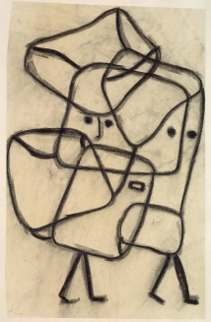  Lesson 3: lines- taking a line for a walk, continuous lines to make abstract patterns.  Lesson 4: Lines- continuous line picture to represent faces, objects, people, looking carefully (observational drawing)  Lesson 5: Using lines to make shapes – create a portrait drawing in the style of Senecio.  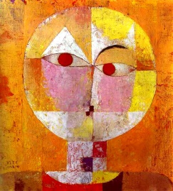  Lesson 6: using lines to create shapes – create a drawing/painting in the style of cat and bird.  