Curriculum Overview for Year 4 SPRING
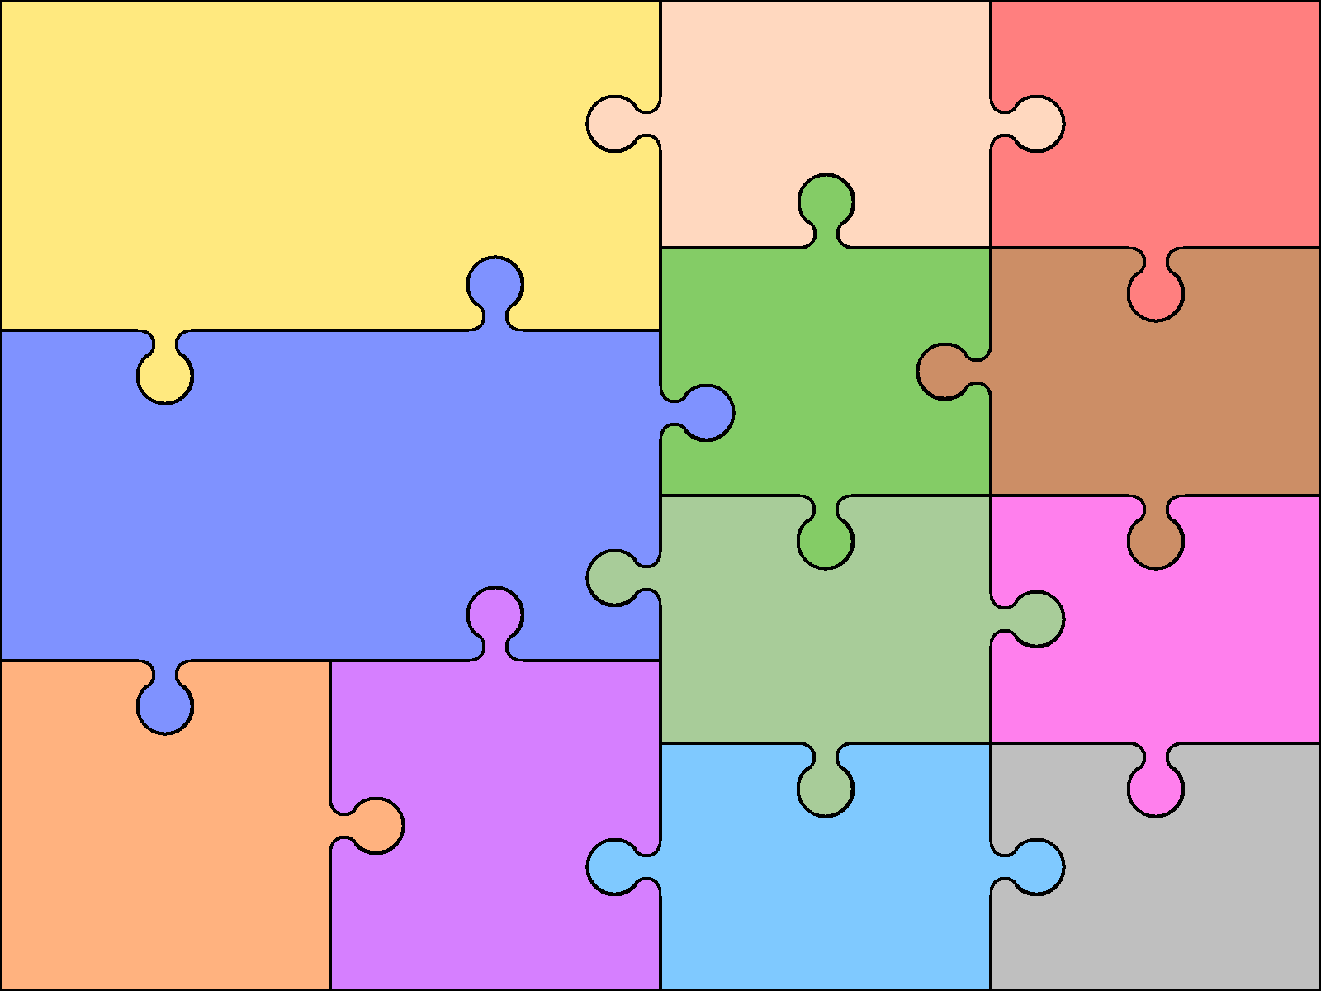  ENGLISH Reading:  • Use knowledge to read  Unfamiliar texts (Nelson Mandela,  • Read a range of fiction and  • Non-fiction.  • Use dictionaries to check meaning.  • Prepare poems to perform – acrostic poems.  • Check own understanding of  Reading. Develop the skill of scanning ahead  STRIDE AHEAD programme – increase the speed of reading  • Draw inferences and make  predictions. | Writing:  • Use dictionary to confirm spellings  - Use THESAURUS to extend vocabulary choice  • Write simple dictated sentences  • Use handwriting joins appropriately  - Explore the concept of THINKIUNG HATS: writing to show an awareness of fact and opinion  • BIG WRITING tasks: eg)  TINGA TINGA STORY |  | Grammar:  • Use a range of conjunctions  • Use perfect tense  • Use a range of nouns & pronouns, propositions  - ISPACE  • Use time connectives  • Introduce speech punctuation  • Know language of clauses  Speaking & listening  • SYNONYMS  • Participate in conversation  • Consider and evaluate different viewpoints  - Online SPAG sessions | Art & Design  - Giacometti figures – African models  - Pastel faces  - Silhouette of African sky | Computing  - Powerpoint quiz related to a country of choice from Africa – include questions and answer section  - Scratch – make own scratch project. Include speech, multiple characters, change of backdrop, sound etc.  - Video about how digestion works (Ipad)  - TYPING skills – copy out text in 10 minutes. Get a words/minute score
 |  |  |  | Design & Technology  - A plate of healthy food – air drying clay | Geography  - Name and locate countries, capitals and cities of Africa  - Identify physical features of named areas of Africa: eg) South Africa, Egypt  - Study of a country within Africa – population, physical features ,festivals, languages,
MATHS:  FRACTIONS:Recognise and show, using diagrams, families of common equivalent fractions. Count up and down in hundredths; recognise that hundredths arise when dividing an object by one hundred and dividing tenths by ten. Solve problems involving increasingly harder fractions to calculate quantities, and fractions to divide quantities, including non-unit fractions where the answer is a whole number. Add and subtract fractions with the same denominator. | Decimals: Recognise and write decimal equivalents of any number of tenths or hundredths. Recognise and write decimal equivalents to Find the effect of dividing a one or two digit number by 10 or 100, identifying the value of the digits in the answer as ones, tenths and hundredths. Round decimals with one decimal place to the nearest whole number. Compare numbers with the same number of decimal places up to two decimal places. |  | Measurement Time: Convert between different units of measure, e.g. hour to minute. Read, write & convert time between analogue and digital 12 and 24 hour clocks. Solve problems involving converting from hours to minutes; minutes to seconds; years to months; weeks to days  Measurement: Money Solve simple measure and money problems involving fractions and decimals to two decimal places. Estimate, compare and calculate different measures, including money in pounds and pence.
 |  |  |  | Modern Languages  - Listen and engage  - Ask and answer questions  - Speak in sentences using familiar vocabulary  - Develop appropriate pronunciation  - Show understanding of words and phrases  - Broaden vocabulary  - Physical Education  - Use running, jumping, catching and throwing in isolation and combination.  - Play competitive games, modified as appropriate.  - Compare performances to achieve personal bests.  - Swimming proficiency at 25m.  - Work towards achieving BAGA 5 award | Music  - Use voice and fife with increasing accuracy, control and expression.  - Follow, copy and improvise.  - Listen with attention to detail.  - Play increasingly more complex tunes  - Begin to appreciate a wide range of live and recorded music.  Religious Education  Following Stockport New Curriculum 2016:
Science  - Animals including humans:  DIGESTIVE SYSTEM RESPIRATORY SYSTEM  CIRCULATORY SYSTEM  MUSCLES.  SKELETON |  | History

